APPLICATION FORM

Thank you for the interest shown in Virtusa. Please take a few minutes of your time to fill in the following details to help us understand your technical skills and personal competencies better.
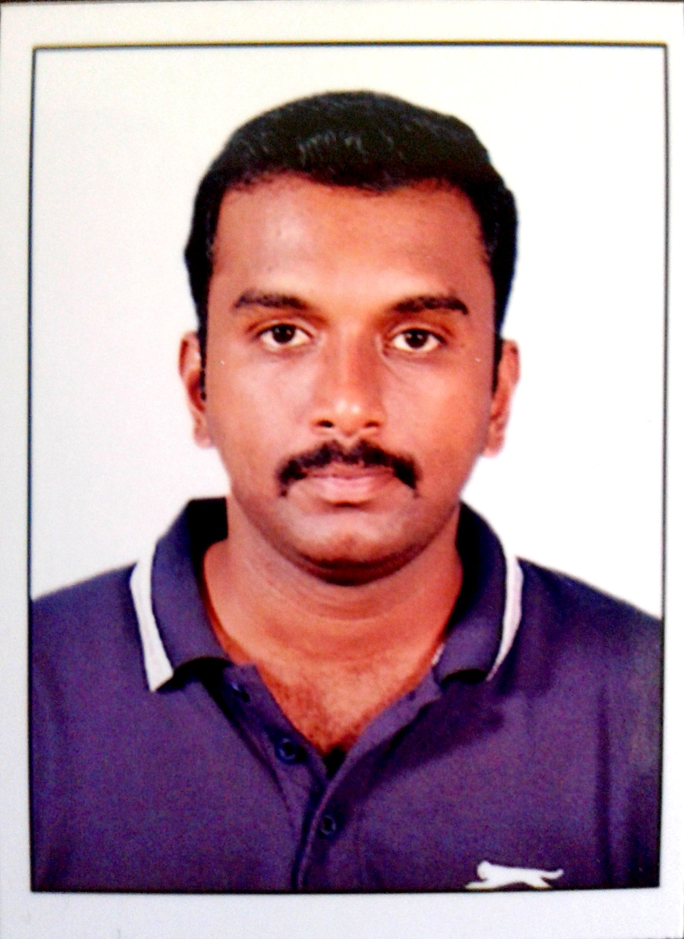te your Passport Size Photograph
Please keep in mind the following when filling up the form:

- Fill in the boxes in the application blank in bold capital
letters unless the content is of a descriptive nature.

- Fill in the details according to the format mentioned
for the date and day.

NAME (As in Passport) |  | Ravindranath / Rajaganapathy  Given Name Surname
Former Name (s) / Maiden Name (if applicable)
Father’s Name: Rajaganapathy
Nationality: Indian |  |  | Social Security Number (if applicable):
Sex: Male |  |  | Marital Status: Married
Date of Birth: 09/05/86  DD MM YY |  |  |  | Place of Birth: Pondicherry
ADDRESS | Present Address |  |  |  | Permanent Address
House No | A-243, Shantiniketan Altair,  Gangaiamman Koil Street |  |  |  | 4, First Main Road,  Tagore Nagar
Locality / City | Chennai |  |  |  | Pondicherry
State | Tamil Nadu |  |  |  | Pondicherry
PIN CODE | 603103 |  |  |  | 605008
Period of Stay | Feb-2015 to Till Date |  |  |  | May-1986 to Till Date
 (Telephone)
 (Mobile Phone) | 9626049603
E-mail ID (Personal) | Ravindar.mca@gmail.com
Instant Messaging System ID:

Passport Details: |  | Available |  | Not Available |  | Applied
Number | : S0824536
Date Of Issue | :11/05/2018
Date of Expiry | :10/05/2028
Place Issue | :Chennai
 |  |  |  |  |  |  | Yes |  | No
Do you have a valid Car Driving License |  |  |  |  |  |  |  |  | No
Have you had any visa rejections? If yes, please mention the nature of visa & reason for rejection. |  |  |  |  |  |  |  |  | No
Are you open to Travel to the USA / Sri Lanka on work for a period of 6 mths/less during a year? |  |  |  |  |  |  | Yes

S.No | Languages Known | Read | Write | Speak
1 | English | Yes | Yes | Yes
2 | Tamil | Yes | Yes | Yes
3
4
Family Information (Parents, Brothers, Sisters, Spouse & Children)
S.No | Name | Relationship | Date of Birth | Age
1 | Rajaganapathy M. | Father | 11-Oct-1948 | 71
2 | Maheswari R. | Mother | 23-Nov-1959 | 59
3 | Bharathi R. | Wife | 13-Dec-1990 | 28
4 | Navdeep Guhan R. | Son | 18-Jan-2017 | 2
5

EDUCATION INFORMATION
Degree | Course | Program (full-time/Part-time) | Elective | College Name and Address | University Name and Address | Duration |  | % | Graduation Date (MM/YY)
X |  | Full-time |  | Petit Seminaire Hr. Sec School, Pondicherry | Matriculation | 06/00 | 04/01 | 77.8 | 04/01
XII |  | Full-time |  | Petit Seminaire Hr. Sec School, Pondicherry | Tamil Nadu State Board | 06/02 | 04/03 | 81.9 | 04/03
Graduation | B.Sc. (CS) | Full-time |  | Tagore Arts College, Pondicherry | Pondicherry University | 07/03 | 05/06 | 68.8 | 05/06
PG | M.C.A | Full-time |  | Pondicherry University, Pondicherry | Pondicherry University | 07/06 | 06/09 | 7.48 | 06/09
Others 1

SSN No. (mandatory if studied in USA or Canada):

* Please mention the last full time degree

ADDITIONAL QUALIFICATIONS/ DIPLOMAS / CERTIFICATES / TRAINING
Please mention any Self learned course /Software /Package)
Program | Institute | Duration |  | % | Division
 |  | From | To

SEMINARS / TRAINING PROGRAMS ATTENDED
S.No | Seminar / Training Program | Conducted by | Duration
S.No | Seminar / Training Program | Conducted by | From | To
1
2
3

MAJOR ACHIEVEMENTS /PUBLICATIONS TO YOUR CREDIT
S.No |  |  |  | Description |  |  |  |  |  |  |  |  | Year
1
2

PROJECT INFORMATION (In ascending order give details of the recent projects)
S.No |  | Title |  |  | Company |  | Client | Platform and Skills used |  | Team Size | Role
1 |  | CBX (Corporate Banking) |  |  | Intellect |  | UAB, GIB &  NBK | Java, Spring MVC,  Spring AOP &  IBatis |  | 4 | Team Lead
2 |  | CAD (Credit Admin) |  |  | Capgemini |  | Standard  Chartered | Java, Struts,  Spring, Hibernate,  & Quartz |  | 3 | Development Lead
3 |  | HEAL (Insurance Portal) |  |  | TCS |  | Vitality  Health | JSF, EJB,  Eclipselink, &  Soap Services |  | 15 | Senior Developer
Please name two known contacts who could be friends / co-workers whom you would like to
recommend for Employment at Virtusa
 |  |  | Name |  |  | Current Company |  |  | E-mail address |  |  | Telephone
 | 1 |  |  |  |  |  |  |  |  |  |  | (Res/Mobile/O)
 | 2 |  |  |  |  |  |  |  |  |  |  | (Res/Mobile/O)

Details of Previous Employers (Starting from your Current Job, covering up to Last 3 Employments)

Please attach a copy of your relieving letter/service certificate for this
Company Name (1) : Tata Consultancy Services |  | Last Designation held: IT Analyst
Address (main office and branch where worked):  Raveline Street, Mumbai.  Sipcot, Siruseri, Chennai. |  | Telephone:
Employment Period: (date, month, year)  From 30/11/2009 To 28/07/2015 | Employee Code/ Personnel No: 330779 |  | Name of Reporting Manager  Ramesh Gurusamy
Name of HR:  Ritu Anand | Contact No. of HR: |  | Email Id of HR:  Ritu.anand@tcs.com
Designation & Department of Reporting Manager  Assistant Consultant | Contact No of Reporting Manager:  9176667665 |  | Email ID of Reporting Manager:  -
Name of Alternative Reporting Manager  Designation & Department of Alternative Reporting Manager | Contact No of Alternative Reporting Manager:  Email ID of Alternative Reporting Manager:
Whether employment is of permanent or temporary nature - ✓ Permanent ◻ Temporary

Agency Details (if temporary or contractual)

Remunerations (CTC pa)  7.6 lakhs | Reason(s) for Leaving  Career Growth

Details of Previous Employers (Starting from your Current Job, covering up to Last 3 Employments)

Please attach a copy of your relieving letter/service certificate for this
Company Name (2) : Capgemini India Pvt Ltd |  |  | Last Designation held: Senior Consultant
Address (main office and branch where worked):  Prestige Cyber Towers, Karapakkam |  |  | Telephone:
Employment Period: (date, month, year)  From 03-Aug-2015 To 27-Jul-2017 | Employee Code/ Personnel No: 78491_FS |  |  | Name of Reporting Manager  Venugopal N
Name of HR:  Raghu Kannan | Contact No. of HR: |  |  | Email Id of HR:  Raghu.kannan@capgemini.com
Designation & Department of Reporting Manager  Manager | Contact No of Reporting Manager:  8668117225 |  |  | Email ID of Reporting Manager:
Name of Alternative Reporting Manager  Designation & Department of Alternative Reporting Manager | Contact No of Alternative Reporting Manager:  Email ID of Alternative Reporting Manager:
Whether employment is of permanent or temporary nature - ✓ Permanent ◻ Temporary
Agency Details (if temporary or contractual)

Remunerations (CTC pa)  10.6 lakhs |  | Reason(s) for Leaving  Career Growth

Details of Previous Employers (Starting from your Current Job, covering up to Last 3 Employments)

Please attach a copy of your relieving letter/service certificate for this
Company Name (3) : Intellect Design Arena |  |  | Last Designation held: Team Lead
Address (main office and branch where worked): |  |  | Telephone:
Employment Period: (date, month, year)  From 3-Jul-2017 To Till Date | Employee Code/ Personnel No: R26 |  |  | Name of Reporting Manager  Padmanabhan S.
Name of HR:  Karthick C | Contact No. of HR:  8939683826 |  |  | Email Id of HR:  Karthick.c@intellectdesign.com
Designation & Department of Reporting Manager  Assistant Vice President | Contact No of Reporting Manager:  9841075463 |  |  | Email ID of Reporting Manager:  Padmanabhan.s@intellectdesign.com
Name of Alternative Reporting Manager  Designation & Department of Alternative Reporting Manager | Contact No of Alternative Reporting Manager:  Email ID of Alternative Reporting Manager:
Whether employment is of permanent or temporary nature - ✓ Permanent ◻ Temporary
Agency Details (if temporary or contractual)
Remunerations (CTC pa)  14.8 lakhs |  | Reason(s) for Leaving  Career Growth

Please account for any and all gaps in education or employment during your tenure.

From | To | Reason: | Complete Address and Location
From | To | Reason: | Complete Address and Location
From | To | Reason: | Complete Address and Location

Organization Chart showing your current position in the current assignment
Key responsibilities at current assignment:

Provide estimate and design for the new enhancement/change request

Work on Proof Of Concept for new features that need to be incorporated in the product

Analyze all Severity issues raised in production and provide fix within a given TAT

Guide the team members during development and issue fixes

Build and Deploy the EAR in offshore environment with managing latest release code in SVN

PERSONAL ASSESMENT
Please put down in five succinct points as what you consider your strengths and Weaknesses.
STRENGTHS | 1 | Quick Learner
STRENGTHS | 2 | Team Player
STRENGTHS | 3 | Ability to perform under pressure
STRENGTHS | 4 | Good Communicator
STRENGTHS | 5 | Commitment towards work
WEAKNESSES | 1 | Difficult to manage work-life balance
WEAKNESSES | 2 | Focus much on details
WEAKNESSES | 3
WEAKNESSES | 4
WEAKNESSES | 5

REFEREES - Please give two references of which one should necessarily be from your Present
Work Place.
Name & Designation | Current Company | Address | Contact Details | No of Mths /  Yrs Of Acquaintance
Padmanabhan S.  Assistant Vice President | Intellect Design  Arena | Perungalathur | 9841075463 | 2 years
Ramesh Gurusamy  Senior Technical Architect | HCL Technologies | Tambaram | 9176667665 | 6 years

* In case your previous employer has closed operations please mention and provide above names and contact details of your supervisors in the above fields.
Which Sport /Hobby / Activity provides you immense satisfaction? State briefly as to why?
What are your short team goals?

What are your long term goals?
Have you ever attended an interview at any of the Virtusa Offices across the Globe in the last 6 months? Yes/No (If yes, mention the details)

Please provide the details if any relatives working in Virtusa
S.No | Name & Designation | Relationship | Empl ID | Location
1
2
3
4
5

Declaration and Authorization

I understand that any employment by Virtusa India Private Limited or its affiliated companies is conditioned upon positive responses from my references, bonding eligibility, continued adherence to Virtusa India Private Limited policies and procedures, applicable rules and regulations and job performance satisfactory at all times to Virtusa India Private Limited.

I consent to take any pre or post-employment examinations as may be required by Virtusa India Private Limited or its permitted agents, its representative, and release Virtusa India Private Limited and its agents from any liability that may arise from such examination.

I authorize an inquiry to be made on the information contained on this application. Former employers and officials of education institutes, named on this application are authorized to give information about me and I release them from all liability for issuing such information.

I hereby attest and warrant that all my answers on this application as well as on all forms completed in conjunction with my employment are true and accurate. I understand that my misrepresentation of facts, failure to disclose information required on this application or material change in my information provided which is not reported to Human Resources shall be cause for dismissal regardless of when discovered by Virtusa India Private Limited

I understand, and authorize, that Virtusa may share my consumer report and/or investigative report with third parties including auditors, government agencies, and clients as necessary.

I hereby declare that the information given by me is true and the certificates or documents submitted are genuine to the best of my knowledge.

Signed: Ravindranath

Name in Block Capitals: RAVINDRNATH R.

Date: 16-Sep-2019

